Requirements and Design Document

ARTSY MINDS

-Varsha Reddy Sripathi

801075913

**Project overview:**

“Artsy Minds” is an application where people interested in art and craft can look for related events that happen in and around the city. The main aim of the application is to create a platform for people to find meetups. Users can check out various groups that are present and look at the connections section for available events. Users can login and signup into the application to use it. Unregistered users can sign up and become registered users but filling a form and entering their details. Unregistered users can access the website as guests and visit the home, about and contact pages. Both unregistered and registered users can look at the available connections, but only registered users can rsvp to the events and create new connections. They can also update or delete connections from their saved connections.

There are two connection topics in this application- art and craft. There are various connections available in each topic. Registered users can log in and view different events in the topics like painting, figure drawing, origami, etc. Users can choose from the different events that they wish to attend. They can save their decision whether attending the event, not attending or may be and can update their decision later as well. Apart from this they can also delete an rsvp from their list of saved connections.

**SITE MAP:**

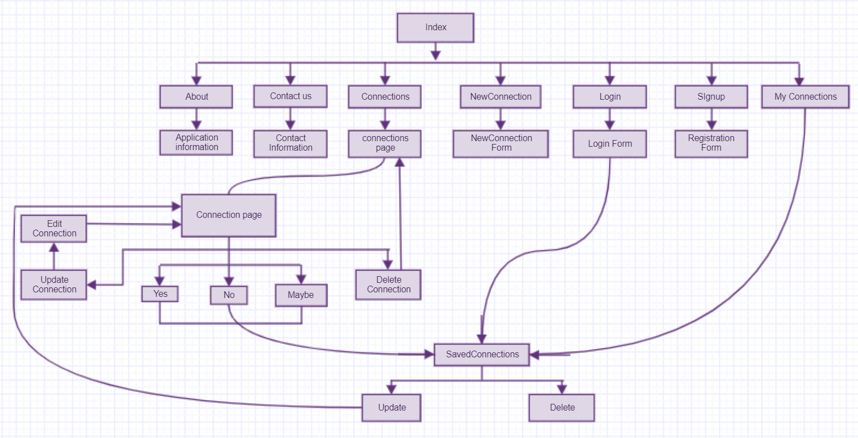

**Page Design:**

**Home Page:**

* Name of the page is index.ejs
* Purpose of the page: This is the main page of the application from which users can navigate to other pages by clicking on different buttons.
* Audience of the page: Both registered users and unregistered users can view this page.
* Home page contains a header with the logo and the name of the application. It also contains a navigation bar which has buttons like sign up, login, start a new connection, Connections to navigate to different pages. In the footer, there are buttons to the about and contact pages

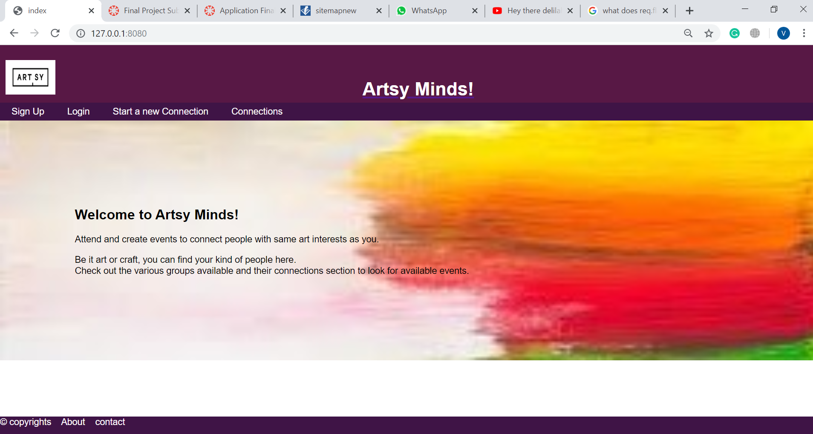

**About:**

* Name of the page is about.ejs
* Purpose of the page: Brief description about the application is found in this page.
* Audience of the page: Similar to the home page this page also can be accessed by registered as well as unregistered users.
* About page contains a header with the logo and the name of the application. It also contains a navigation bar which has buttons like sign up, login, start a new connection, Connections to navigate to different pages. In the footer, there are buttons to the about and contact pages

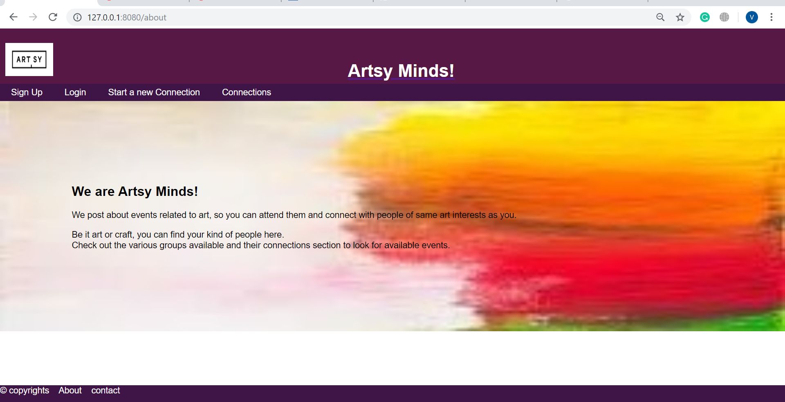

**Contact:**

* Name of the page is contact.ejs
* Purpose of this page: This page contains information regarding the contact details of the administrator of the application and how to contact them using different platforms.
* Audience of the page: This page is accessible to everyone.
* Contact page contains a header with the logo and the name of the application. It also contains a navigation bar which has buttons like sign up, login, start a new connection, Connections to navigate to different pages. In the footer, there are buttons to the about and contact pages.

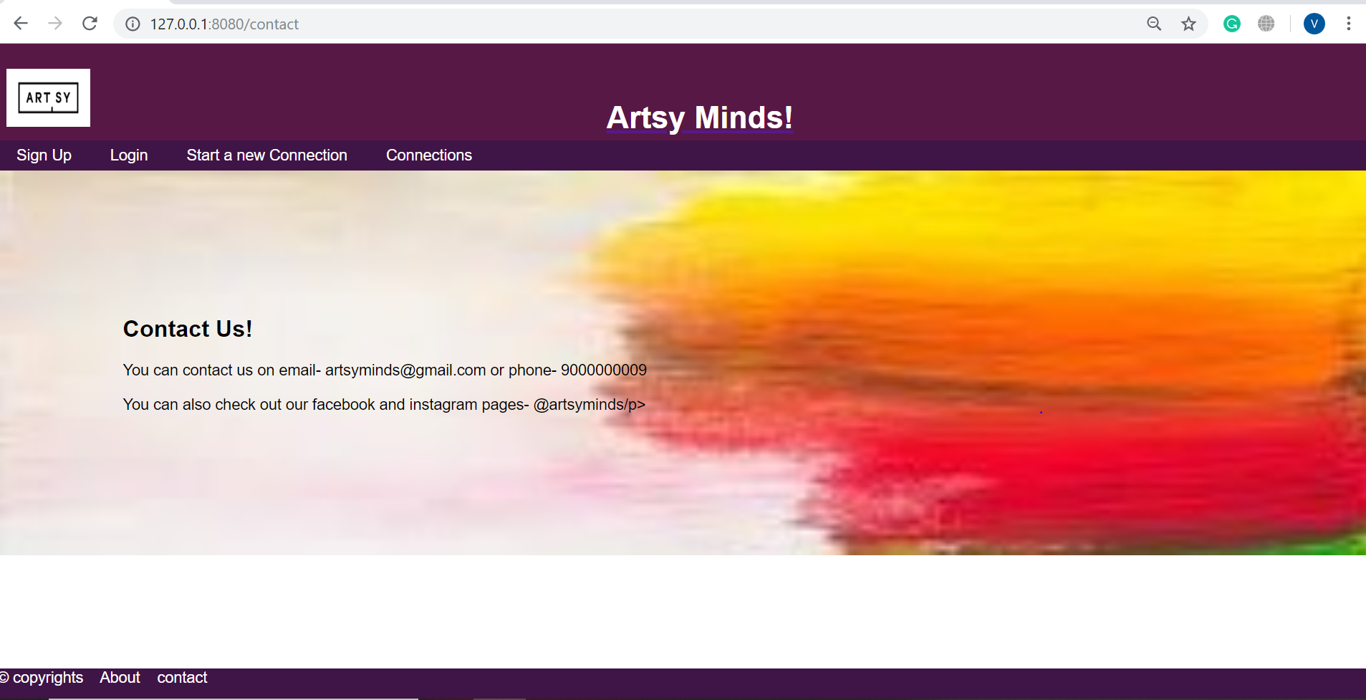

**Connections:**

* Name of this page is connections.ejs
* Purpose of this page: This page contains the list of all the events available currently for the users. Under each topic, the available connections are listed. Users can click on each event and check it out or update and delete their rsvp.
* Audience of the page: This page is accessible to everyone.
* Connections page contains a header with the logo and the name of the application. It also contains a navigation bar which has buttons like sign up, login, start a new connection, Connections to navigate to different pages. In the footer, there are buttons to the about and contact pages.

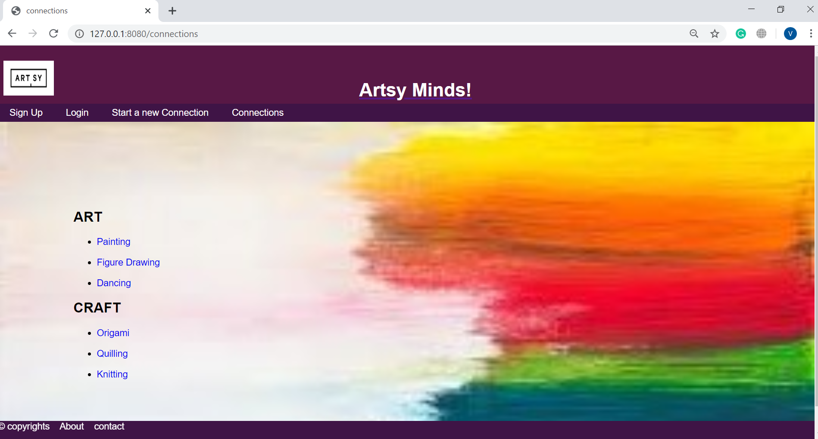

**Individual Connection:**

* Name of this page is connection.ejs
* Purpose of page: Connection page contains detailed description of the event. Description includes name of the connection, image, location, date, time, details and rsvp of whether user wants to attend the event or not.
* Audience of the page: Both registered users and unregistered can view this page, but only registered users can change the rsvp to the event.
* When a registered user gives an rsvp, they will directed to the Saved Connections page.
* Connection page contains a header with the logo and the name of the application. It also contains a navigation bar which has buttons like sign up, login, start a new connection, Connections to navigate to different pages. In the footer, there are buttons to the about and contact pages.

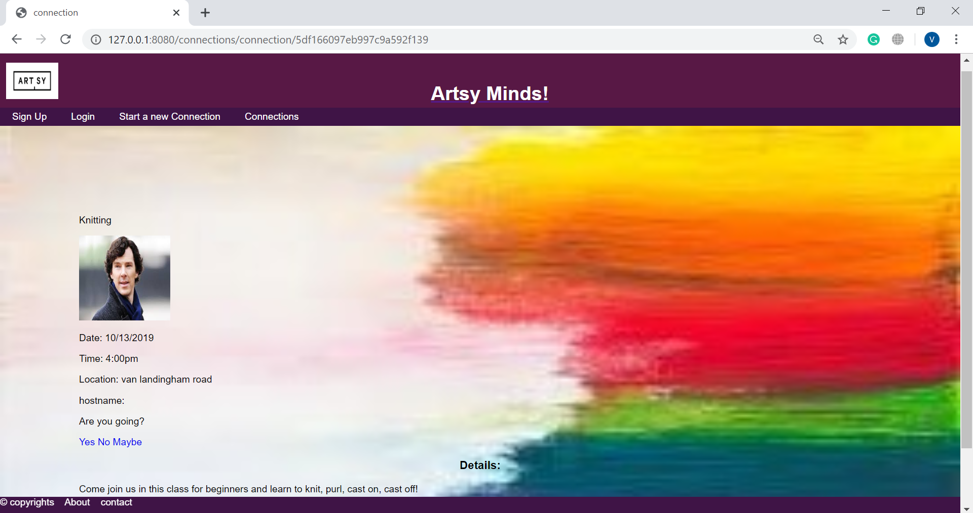

**Start a New Connection:**

* Name of the page is newConnection.ejs
* Purpose of page: The purpose of this page is to create a new connection.
* Audience of the page: Only registered users can start a new connection after logging in.
* This page has a form submission to create a new connection. This form contains details of the connection like connection name, connection topic, date, time, location.
* After the user fills the form, they can click on the create connection button to create a new connection.
* Validation: While filling out this form, users should make sure they enter valid details into each input field.

1. The connection name must be alphabets and have a minimum length of 3.
2. The location must have a minimum length of 5.
3. The details must have a minimum length of 10.

* Start a new connection page contains a header with the logo and the name of the application. It also contains a navigation bar which has buttons like sign up, login, start a new connection, Connections to navigate to different pages. In the footer, there are buttons to the about and contact pages.

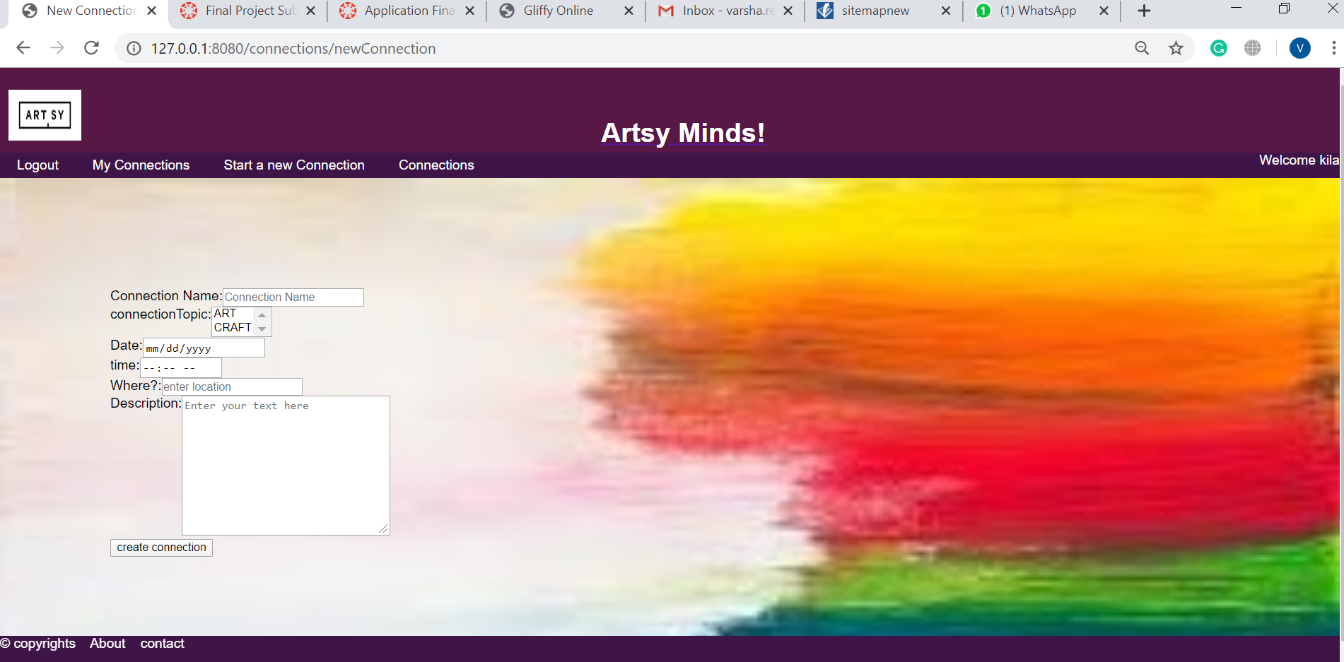

**Login:**

* Name of the page is login.ejs
* Purpose of page: With this page, the registered users can log into the application by giving their username and password.
* Audience of this page: All users can view this page, but only registered users can enter their details an actually log into the application.
* After filling the details users can click on submit button to log into the application.
* Validation: Users should make sure to give valid username and password.

1. The username should be an email id.
2. The password must be 8-24 characters long and should include lower case, upper case, numbers and special characters.

* Login page contains a header with the logo and the name of the application. It also contains a navigation bar which has buttons like logout, sign up, login, start a new connection, Connections to navigate to different pages. In the footer, there are buttons to the about and contact pages.
* By clicking on the logout button, the user can log out of their account and will be redirected to the home page.

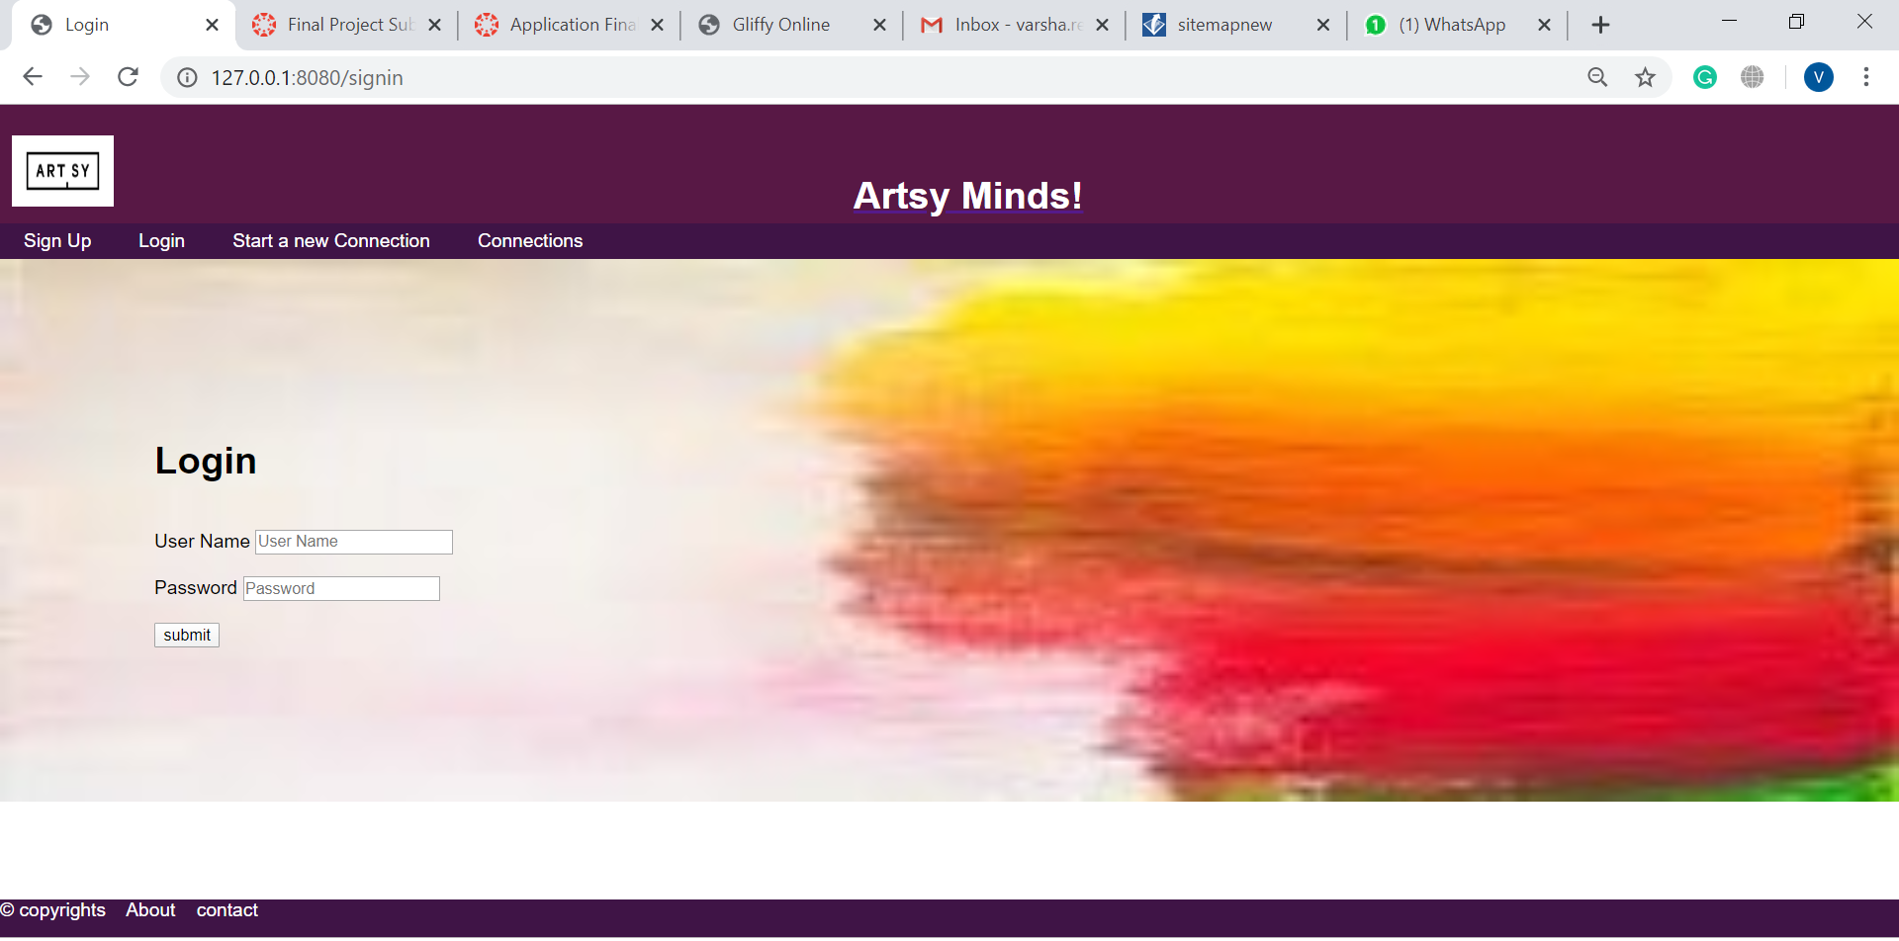

**My Connections:**

* Name of page is savedConnections.ejs
* Purpose of the page: In this page, registered users can view the connections that they gave rsvp to. They can also update or delete the rsvp.
* Audience of the page: Only registered users can view and make changes to this page after logging in.
* This page contains a list of connections which are saved for that particular user. It also contains two buttons- update and delete.
* By clicking on the update button, users can change their rsvp to that connection and by clicking on delete button, they can completely delete the connection from their saved connections list.
* My Connections page contains a header with the logo and the name of the application. It also contains a navigation bar which has buttons like sign up, login, start a new connection, Connections to navigate to different pages. In the footer, there are buttons to the about and contact pages.

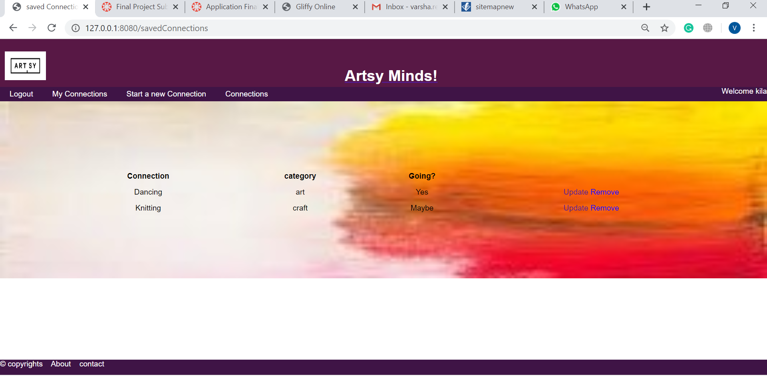

**SignUp:**

* Name of this page is register.ejs
* Purpose of this page: Using this page, unregistered users can sign up and become registered users.
* Audience of the page: Unregistered users can view and fill out this page to create an account.
* After filling the form, by clicking on register button, users can create an account.
* Validation: While filling out this form, users should make sure they enter valid details into each input field.

1. Username must be an email id.
2. Password must be 8-24 characters and must include uppercase, lowercase, special characters and numbers.
3. City must consist only alphabets and spaces.
4. State must consist only alphabets and spaces.
5. Zip code must be numbers.
6. Country must consist only alphabets and spaces.

* Sign up page contains a header with the logo and the name of the application. It also contains a navigation bar which has buttons sign up, login, start a new connection, Connections to navigate to different pages. In the footer, there are buttons to the about and contact pages.

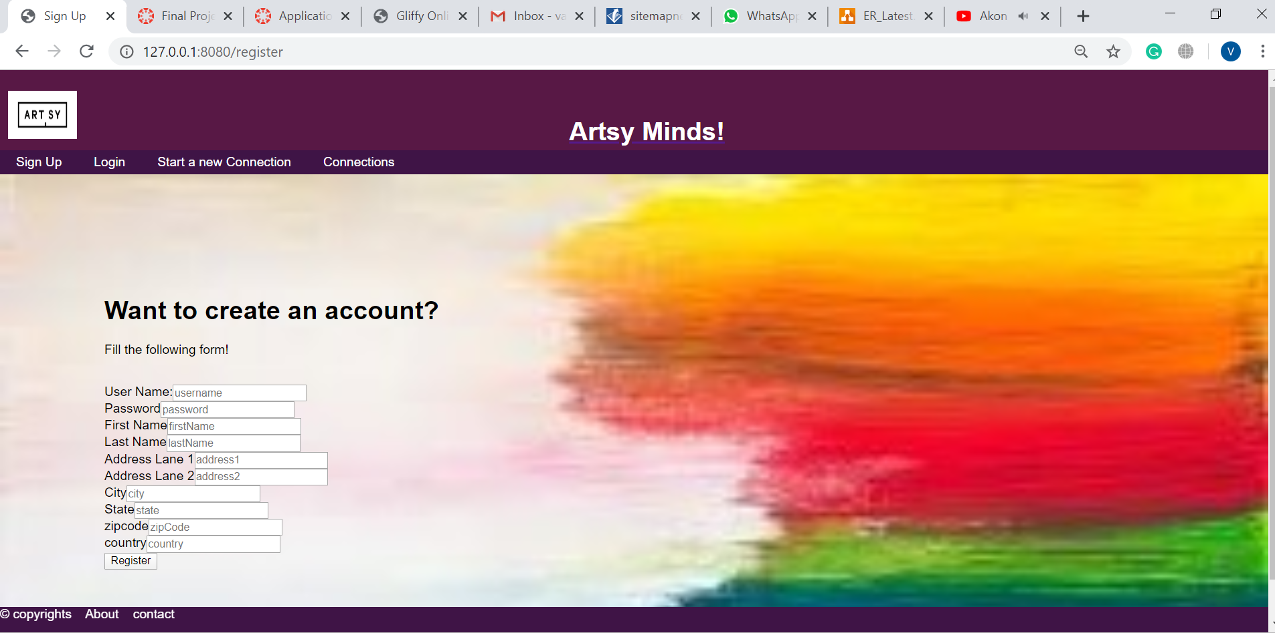

**Edit Connection:**

* Name of the page is edit.ejs
* Purpose of page: The purpose of this page is to edit or delete an existing connection.
* Audience of the page: Only registered users can edit the connection after logging in.
* This page has a form submission to edit the existing connection. This form contains details of the connection like connection name, connection topic, date, time, location, which are already filled with the current details of the connection.
* Registered users can change these details in the form to edit the connection.
* They can also completely delete the connection by clicking on the delete button, which is present in the individual connection page.
* After the user fills the form, they can click on the create connection button to edit the connection.
* Validation: While filling out this form, users should make sure they enter valid details into each input field.

1. The connection name must be alphabets and have a minimum length of 3.
2. The location must have a minimum length of 5.
3. The details must have a minimum length of 10.

* Edit connection page contains a header with the logo and the name of the application. It also contains a navigation bar which has buttons like sign up, login, start a new connection, Connections to navigate to different pages. In the footer, there are buttons to the about and contact pages.

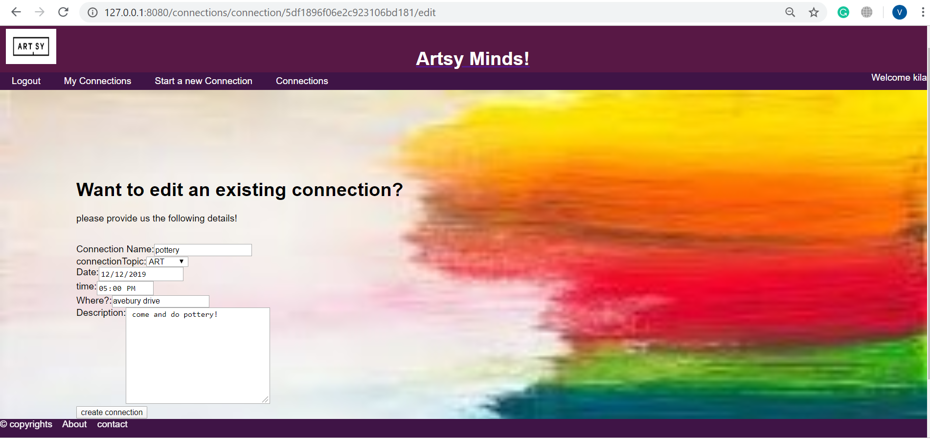

**ER Diagram**

Entities

